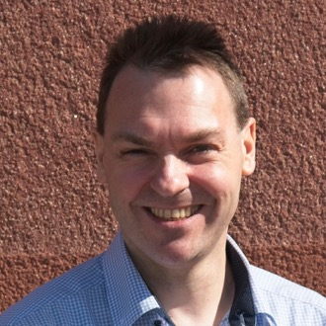 | Torsten Uhlmann  AGYNAMIX® | Senior Full Stack Software Engineer & Consultant
Buchenweg 5, 09380 Thalheim, Germany | tuhlmann@agynamix.de | +49 151 12412427 | agynamix.de
LinkedIn: linkedin.com/in/torstenuhlmann | GitHub: github.com/tuhlmann | Xing: xing.com/profile/Torsten_Uhlmann2

Professional Summary
Senior Full Stack Software Engineer with nearly 30 years of experience delivering robust, high-performance software solutions across diverse industries. Operating through AGYNAMIX, I specialize in taking complex, system-critical applications from prototype to production—whether leading development efforts or integrating into distributed teams, bridging intricate backend architectures with modern, responsive frontend frameworks. I love learning new things and meeting new people. Over the years I have worked with a plethora of different programming languages—from Cobol, C++, and Java through Scala and Clojure to Rust and TypeScript. Technologies change, developer roles change, but the desire to create something useful always stays strong. I authored the book "Lift Web Applications How-To" (Packt Publishing, 2012) and regularly contribute to open-source projects on GitHub. I am particularly good at integrating into teams and getting myself deeply involved in the subject matter.

Core Services & Consulting
End-to-End Application Development — Complete solutions from requirement gathering through implementation and deployment.
High-Performance Backend Systems — Scalable, concurrent backends using Rust, Scala, and Java.
Modern Frontend Architecture — Responsive, client-centric UIs with ReactJS, TypeScript, and Angular.
Cloud & DevOps Integration — Mission-critical deployments and containerization with AWS, Docker, and Ansible.

Technical Skills
Languages (expert): Scala, Java, TypeScript, JavaScript, Rust, C++
Languages (proficient): Kotlin, Go
Languages (competent): Python, Ruby, Perl, Groovy, C#, Clojure, ClojureScript
Frontend Frameworks (expert): ReactJS, Angular, AngularJS, VueJS, SolidJS
Backend Frameworks (expert): Lift (Scala), Spring (Java)
Desktop Frameworks (proficient): Jetpack Compose for Desktop, Eclipse RCP, SWT / JFace
Databases (expert): PostgreSQL, MongoDB, Oracle, MySQL
Cloud & DevOps (proficient): AWS, Docker, Ansible, Linux
Methodologies (proficient): Agile / Scrum, SAFe, CI/CD, Test-Driven Development
Languages: German (Native) | English (Full professional proficiency) | Russian (Elementary)

Work Experience
 | Senior Frontend Developer | Aug 2024 – May 2025  TXODDS, Ltd.  VueJS 3, TypeScript, JavaScript, Docker  Developed multiple frontend applications for the TX-Scores professional scouting network—a platform connecting the sports betting ecosystem to ultra-low latency sports odds delivery.  - Built several frontend applications for the tx-scores project using VueJS 3 with TypeScript.  - TX-Scores is a professional scouting network—not casual coverage. A community of scouts and analysts with real-time dedicated analyst oversight for every game.  - Docker-containerized deployment pipeline.

 | Senior Fullstack Developer | Feb 2022 – Aug 2022  iCombine UG  Scala, Lift, AngularJS, React, TypeScript, PostgreSQL  Led the migration of an expert talent-pool and project-matching platform from AngularJS to React, using a bottom-up approach that combined both component types during the transition.  - Architected and implemented bottom-up migration strategy from AngularJS to React, enabling co-existence of both component types during the transition.  - Worked with Scala and the Lift web framework for backend services.  - Platform connects experts to the right project roles, trainings, and peers via skills, interest, and availability matching.

 | Senior Fullstack Developer | May 2019 – Jul 2024  Scaled Agile, Inc.  Scala, Lift, Angular 12, AngularJS, TypeScript, Docker, PostgreSQL, AWS  Key role in developing and modernizing an online planning platform for remote learning, PI planning, and collaborative events. Five-year engagement with significant product growth.  - Expanded Collaborate's reach by integrating collaborative planning features such as remote PI planning and online training classes.  - Backend built with PostgreSQL, Scala, and Lift; containerized and deployed on AWS.  - Frontend migrated from legacy AngularJS 1 to Angular 12 / TypeScript within an NX workspace.  - Designed a push-based data warehouse integration.

 | Senior Software Developer | Jul 2013 – Feb 2019  Ascendant, Inc.  Scala, Lift, Go, AngularJS, MarkoJS, JavaScript, Docker, MongoDB  Senior engineer and mentor in a small team of high-profile developers building a multi-tenant SaaS compliance and risk management suite. Balanced industry-specific compliance requirements with engineering problem-solving over a 5.5-year engagement.  - Implemented state-of-the-art frontend with AngularJS and MarkoJS; backend with Scala, Lift, and MongoDB.  - Mentored junior developers while furthering expertise in financial services, asset classes, and trading patterns from a compliance perspective.  - Some services implemented in Go.  “Torsten worked with our team at Ascendant for roughly six years. He was one of our earliest developers and served as a senior engineer and mentor to junior developers. He thrived in our distributed, virtual environment and handled the pressures related to a multi-tenant SaaS platform with grace. Were it not for our acquisition by private equity and shifting capital expenditures, he would remain with us indefinitely, as I would want.”  — Neil Visnapuu, Managing Director, Ascendant Compliance Management

 | Scala & Lift Consultant | Mar 2013 – Jul 2013  Twisp, Inc.  Scala, Lift, MySQL, Squeryl  Developed a Lift-based personalized information engine application.  - Built a multi-user Scala/Lift web application using MySQL, Apache Shiro, and Amazon Cloudsearch.

 | Scala & Lift Consultant | Nov 2012 – Apr 2013  Underscore Consulting  Scala, Lift, MongoDB, Cloudbees  Developed part of a Scala/Lift client application for an innovative real-time interactive NFC platform (TagTrail) for a US corporation. Delivered a rich reporting tool as an international (D, UK, AU) team.  - Took responsibility for—and delivered—a rich reporting tool within a cloud-based NFC/QR-code marketing campaign tracking platform.  - Collaborated in a small international team (Germany, UK, Australia).  “He brought technical knowledge, especially with Lift, Scala, and Angular. He worked with the customer to understand their needs. As well as generally contributing to the project, he took on responsibility for (and delivered) a rich reporting tool.”  — Richard Dallaway, Partner, Underscore Consulting LLP

 | Senior Software Developer | Sep 2011 – Sep 2012  Sgrouples, Inc. (now MeWe.com)  Scala, Lift, JavaScript, MongoDB, AWS  Implemented system-critical features and managed AWS deployment for a secure, group-based privacy-conscious social communication platform.  - Independently implemented many business-critical features of the application, managed deployment on AWS servers, performed MongoDB migrations and maintenance.  - Built frontend JavaScript/CSS/HTML5 components using jQuery alongside Scala/Lift backend development.  - Significantly contributed to evolving the application from prototype to production readiness within a few months.  - Worked in an internationally distributed remote team; communication in English.  “It has been my greatest pleasure working with Torsten. He has proven himself capable of taking on any task or challenge given to him. He is an excellent Scala developer, an expert in the Lift framework, and has demonstrated mastery of several types of databases. He is a committed, hard-working, resourceful programmer, a faithful team player, and a true pleasure to work with. Whatever future teams or projects he joins will be lucky indeed.”  — Jonathan Wolfe, Ph.D., Chief Scientist, Sgrouples.com

Software Developer / Sub-Project Lead | Mar 1996 – Sep 2011
T-Systems
Java, C++, Perl, Oracle, Eclipse RCP, JBoss, Cobol, CORBA, PHP
15-year engagement spanning multiple major projects at T-Systems (formerly T-Systems GEI GmbH and T-Systems SL SI), progressing from COBOL conversion work to leading sub-projects and building high-performance enterprise applications.
- Maintained and extended a mid-sized Eclipse RCP application for the in-house test department (EMF, Teneo/Hibernate, Oracle, JDBC).
- Extended a data transformation framework for mass-data migration (HP-Tandem NonStop, Oracle 9i); classifiable as EAI/EII system.
- Created an Eclipse RCP DSL application using the XText framework, enabling non-developers to write business rules.
- Built and extended a Perl-based distributed test framework for cross-machine automated system testing.
- Designed and developed a high-performance data extraction application processing millions of records from multiple Oracle schemas; multi-threaded for throughput.
- Developed invoice generation system using LaTeX with email delivery (optional encryption/signing); scalable multi-process C++ backend communicating via CORBA with an Oracle database and Java/J2EE frontend.
- Developed an Online Payment Platform (Santorin) using J2EE on BEA WebLogic and Portal with Oracle; and a CORBA bridge linking a legacy server application to a Tomcat server farm.
- Created COBOL converters for customer invoice data targeting AFP printers; developed Java GUI applications for invoice layout specification.
- Sub-project lead from August 1999.
“The freelancer has a very broad spectrum of technological knowledge. As architect and developer he worked confidently with object-oriented programming concepts. All work was completed to our fullest satisfaction on time. Beyond the concrete programming tasks he showed very high engagement. He identified errors and improvement potential in requirements and implementation. He supported his colleagues beyond his own area of responsibility. Working with him was very pleasant. He was a treasure for the project team.”
— Project Center Team Leader, T-Systems GEI GmbH
“The consultant is proficient in C++ and Java; he works confidently with object-oriented programming concepts. All work was completed to our fullest satisfaction on time. I would very much like to work with him again.”
— Project Leader, T-Systems

JSF Developer | Jun 2008 – Oct 2008
1822direkt Sparkasse Frankfurt
Java, JSF, JBoss, Tomcat, LaTeX
Developed a JSF frontend for managing and creating customer correspondence at a German bank. Letters were generated template-based via a LaTeX backend and delivered as PDF or sent to a high-volume printer.
- JSF 1.2 with MyFaces on Tomcat 5 and JBoss.
- LaTeX-based document generation pipeline for customer printables.

 | Software Developer | Apr 1995 – Apr 1996  G & K Datensysteme GmbH  C, Pascal, MS-DOS  Developed drivers and associated software for retail cash registers, scanners, and printers used with the client's point-of-sale software. Also contributed to development of the retail cash register software itself.  - Driver development for cash registers, scanners, and printers.  - Contributed to the core POS application.

 | Software Developer | Feb 1994 – Apr 1994  Leicher GmbH  C++, MS-DOS  Developed converter software for converting data between the Datanorm industry standard and the client's in-house software standard.

Software Developer | Mar 1993 – Jun 1993
Jahn Büroorganisation
Pascal, MS-DOS
Developed management software for tracking printers and copiers leased by the client to its customers.

Own Products & Innovations
 | AGYNAMIX Invoicer | 2025 – present  Kotlin, Jetpack Compose for Desktop, SQLite, GoBD  https://invoicer.agynamix.de  Modern desktop invoicing application for freelancers and small businesses in the DACH market. Fully GoBD-compliant with ZUGFeRD and XRechnung e-invoice support.  - Cross-platform (Windows, macOS, Linux) with a modern Jetpack Compose UI.  - Features: customizable invoice templates, automatic numbering, VAT calculations, payment tracking, customer management, and reporting.  - Offline-capable with local data storage—no cloud dependency. Emphasizes data sovereignty and financial management for professionals.

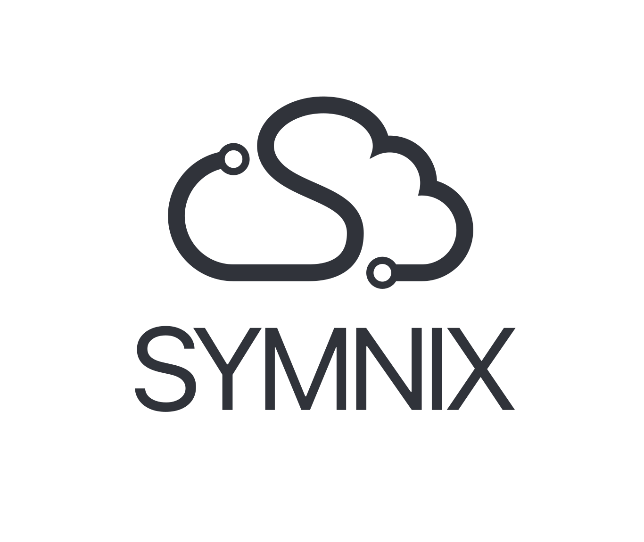 | Symnix -- Cloud Provisioning Platform | 2022 – present  Rust, TypeScript, React, PostgreSQL, Docker  https://symnix.com  Co-founded web application with a high-performance Rust / PostgreSQL backend for cloud server setup and provisioning.  - Allows individuals and organizations to create, manage, and monitor multiple hosts with multiple installed applications.  - Streamlines server management using latest industry standards and best practices; Docker-containerized deployment.

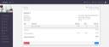 | AGYNAMIX Numerix | 2015 – 2017  Clojure, ClojureScript, MongoDB, Reagent, re-frame  https://github.com/tuhlmann/numerix  Multi-tenant tool for freelancers and small companies with modules for time tracking, invoice generation, document management, knowledge base, chat rooms, calendar, and user management.  - Invoice generation from tracked time; PDF output via Flying Saucer.  - Role-based permissions system similar to Apache Shiro's wildcard permissions.  - Multi-document upload and knowledge base with notifications.

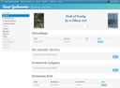 | Unser Gartenverein (Garden Community Manager) | 2012 – 2016  Scala, Lift, JavaScript, MongoDB  https://github.com/tuhlmann/gartenverein  Hosted web application for managing German garden communities (allotment associations): tenant management, meter readings, invoicing, document management, and shared calendar.  - Manages water and power meter readings collection and invoicing.  - Dashboard overview with quick navigation to all areas.

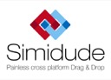 | AGYNAMIX Simidude | 2008 – 2011  Java, SWT, JFace, Install4j  https://github.com/tuhlmann/simidude  Cross-platform network clipboard and file sharing tool. Automatically discovers other instances on the local network and enables drag-and-drop file transfer and clipboard synchronization across machines.  - Runs on Windows, Linux, macOS, and in virtual machines.  - Automatic LAN discovery; drag-and-drop file/directory transfer between connected computers.  - Available as 30-day trial with online payment.

 | AGYNAMIX Net-Herald | 2005 – 2015  Java, Eclipse RCP, PostgreSQL, Spring, OPC, GEF  https://www.agynamix.de  First AGYNAMIX product—monitoring software for water supply companies. Server-side Java application with Eclipse RCP GUI for real-time data visualization.  - Server: Java 5, JMX, Spring, PostgreSQL, ESB bus architecture for component decoupling.  - GSM modem connectivity for SMS alerts; OPC (OLE for Process Control) library for connecting to existing industrial software.  - Eclipse RCP client using GEF for charts and real-time data visualization.  - Led a dedicated team to bring the product to market.

Education
Diploma in Computer Science (Dipl.-Inf.) | 1991 – 1996
Technical University Chemnitz-Zwickau | Computer Science
Equivalent to a Master's degree. Focus areas included databases and algorithms. Started working at a major telecommunications company before finishing studies.

Publications
Author: Lift Web Applications How-To | Packt Publishing, 2012
Practical guide to building web applications with Lift, the Scala web framework. Published by Packt Publishing.

Training & Speaking
Java Trainer | Sep 2011 – Dec 2011
ML Consulting | Dresden and Berlin, Germany
Taught several Java and programming basics courses. Received very good ratings from students; the consulting facility manager requested return engagements.
Speaker -- Lift 3 & Client-Side JavaScript Frameworks | Jun 2013
Scala Days 2013 | New York, USA
Conference talk about Lift 3 and integrating client-side JavaScript frameworks with the Scala web framework.
Speaker -- Lift 3 & Client-Side JavaScript Frameworks | Dec 2013
Scala Exchange 2013 | London, UK
Conference talk about Lift 3 and integrating client-side JavaScript frameworks with the Scala web framework.

About Me
I grew up in the beautiful Ore Mountains of Germany, where I still live. I'm married to my wife Silvia and we have two kids. In eighth grade I was given a programmable BASIC calculator with a memory of 1024 bytes. Though very limited, it allowed me to create useful solutions for school and helped me reduce my homework. After secondary school I was admitted to study computer science at Chemnitz Technical University—remarkable given that in the last year of school, in 1988 in East Germany, I was told I would never be allowed to study as a Christian. Just a year later the history of our nation completely changed. I finished my studies in 1996 and started working for a large IT supplier in different projects until 2004, when I started my freelancing career.
Volunteer Translator  For many years I have been volunteering as a translator for international guests and events. | Coffee Enthusiast  I'm a coffee aficionado and vastly enjoy a good cup of espresso. I wonder if more than a decade of Java programming nurtured this habit. | Sourdough Bread Baker  A few years ago I started my bread baking adventure. After many mishaps we now mill our own flour and bake our own sourdough bread. Apart from being healthier, this process puts my feet back on reality—especially when most of the things I work with are only virtual.

Open Source & Community
BibleTime — A Bible study software for Unix and KDE. Project consisted of multiple developers, translators, and testers. Initiated and coordinated by me.
KPriMa — A print manager for managing print jobs across various devices under Unix and KDE.
KMsgModem — A program for reading fax and voice messages from the USR Message Modem, running under Unix and KDE.
Newtonlink Modules — Perl modules for the Newtonlink program (a Unix communication tool for the Apple Newton MessagePad). Converts Newton data into a meta format or the format of selected Unix programs.
Interested in working together? I'd love to hear from you
tuhlmann@agynamix.de or +49 151 12412427
agynamix.de/resume | Last updated: March 2026

